**LAB TASKS**

**Q1:**

**CODE  
RESULTS**

#include <LiquidCrystal.h>

// Creating an instance of the Liquid Crystal class with the specified pin connections

LiquidCrystal lcd(12, 11, 5, 4, 3, 2);

void setup() {

lcd.begin(16, 2); // Initializing the LCD with 16 columns and 2 rows

}

void loop() {

lcd.setCursor(2, 0); // Setting the cursor position to column 2, row 0

lcd.print("Abeez and Auj"); // Printing the text "Abeez and Auj" at the current cursor position

lcd.setCursor(1, 1); // Setting the cursor position to column 1, row 1

lcd.print("ME201002-201065"); // Printing the text "ME201002-201065" at the current cursor position

}

**Working during lab session on Question 1**

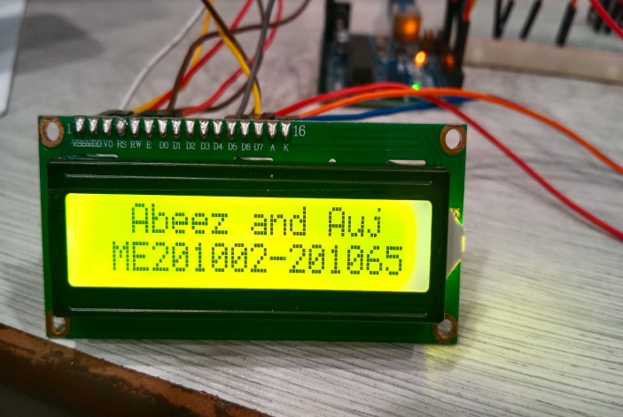

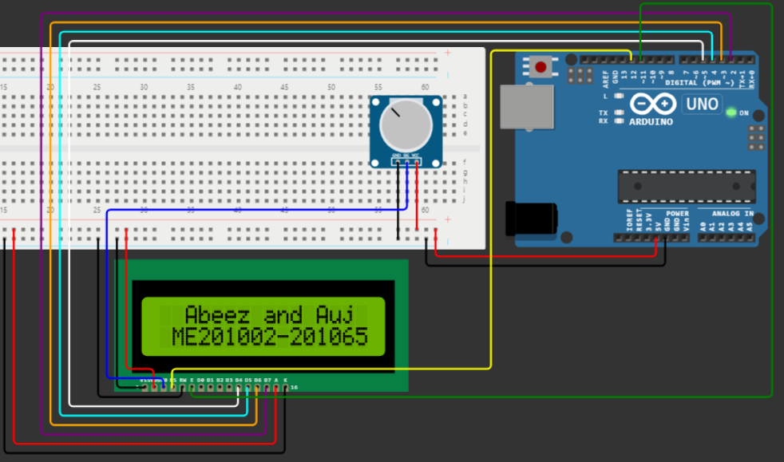

**Q2:**

**CODE**

#include <LiquidCrystal.h>

// Creating an instance of the LiquidCrystal class with specified pin connections

LiquidCrystal lcd(12, 11, 5, 4, 3, 2);

void setup() {

lcd.begin(16, 2); // Initializing the LCD with 16 columns and 2 rows

}

void loop() {

lcd.clear(); // Clearing the LCD display

delay(500); // Introducing a delay of 500 milliseconds

lcd.setCursor(2, 0); // Setting the cursor position to column 2, row 0

lcd.print("Abeez and Auj"); // Printing the text "Abeez and Auj" at the current cursor position

lcd.setCursor(1, 1); // Setting the cursor position to column 1, row 1

lcd.print("ME201002-201065"); // Printing the text "ME201002-201065" at the current cursor position

  delay(500); // Introducing another delay of 500 milliseconds before the next iteration

}

**RESULTS**

**Working during lab session on Question 2**

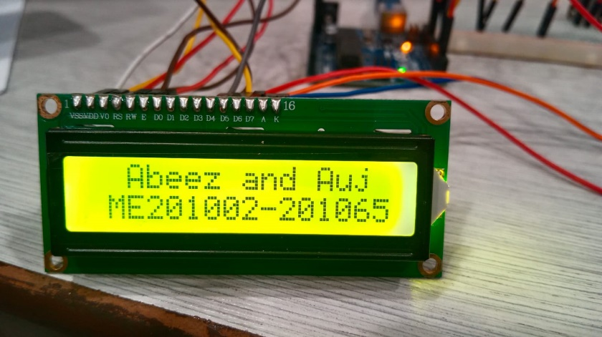

**The same Circuit but develops a code that blinks the text that is written on LCD Screen.**



**Q3:**

**CODE**

#include <LiquidCrystal.h>

LiquidCrystal lcd(12, 11, 5, 4, 3, 2); // Creating an instance of the Liquid Crystal class with specified pin connections

void setup() {

lcd.begin(16, 2); // Initializing the LCD with 16 columns and 2 rows

}

void loop() {

lcd.setCursor(2, 0); // Setting the cursor position to column 2, row 0

lcd.print("Abeez and Auj"); // Printing the text "Abeez and Auj" at the current cursor position

lcd.setCursor(1, 1); // Setting the cursor position to column 1, row 1

lcd.print("ME201002-201065"); // Printing the text "ME201002-201065" at the current cursor position

lcd.scrollDisplayLeft(); // Scroll the entire display one position to the left

 delay(200); // Introducing a delay of 200 milliseconds to control the scrolling speed

}

**Working during lab session on Question 3**



**The text that is written on the LCD Screen is scrolling to the left side with the help of CODE**



**POST LAB TASKS**

**Q1: How many pins are there in your LCD screen? List down all of them with their usage.**

**ANSWER:** There are 16 pins in the LCD (Liquid Crystal Display) Screen. Names and usage of pins are shown below:

1. VSS: Ground (OV).
2. VDD: Power Supply (+5V)
3. VO: Contrast adjustment
4. RS (Register Selector): Selects between data register (RS=1) and command/instruction register (RS=0)
5. RW (Read/Write): Selects between read and write operations (usually grounded for write).
6. E (Enable): Enables writing to the registers when high.
7. D0 to D7: Eight data lines for sending information (not all are always used, especially in 4-bit mode).
8. A (Backlight Anode): Backlight connection.
9. K (Backlight Cathode): Backlight connection.

**Q2: Search “LiquidCrystal” library on the Arduino website. What is the latest release available? How many functions are available in this history? List down all of them.**

**ANSWER:** I’ve searched for the "LiquidCrystal" library on the Arduino website and found that the latest release available is **v2.5.7.** However, listing all functions from its entire history would be a very long and potentially unnecessary task.

* **List the major functions available in the current version (v2.5.7):** This would be a manageable list of the key functions you'd likely use to control your LCD. I can provide you with this list directly.
* **Navigate the function reference for v2.5.7:** You can access the official reference page for the LiquidCrystal library on the Arduino website: [https://m.youtube.com/watch?v=_C0TewvJ5z0.](https://m.youtube.com/watch?v=_C0TewvJ5z0) This page has a detailed list of all functions available in the current version, along with their descriptions and syntax. You can easily browse and search for specific functions here.

**Check the GitHub repository for older versions**: If you're interested in functions from previous versions of the library, you can explore the GitHub repository: [https://github.com/arduino-libraries/LiquidCrystal.](https://github.com/arduino-libraries/LiquidCrystal) This repository allows you to browse different releases and view the corresponding function lists.

**Q3: Which Arduino project would like you to build if you were given 3 LCD screens?**

**ANSWER:** I have an exciting Arduino project idea for 3 LCD Screen that is a **News Ticker**, in which headlines scroll across one or all screens, updating every few seconds. You could integrate RSS feeds or other online data sources.

**Signature of Lecturer: ______________________**